2010National Graduate Mathematical Contest in ModelingCtitle
Neurons in the taxonomic and identification
Brain structure and function in vivo most complex organization, which contains hundreds of billions of nerve cells (neurons). Human Brain Project(Human Brain Project, HBP)was designed to study neural information on the world to establish common standards database, multi-disciplinary integration of large amounts of data, speed up the understanding of the human brain.
As the basic unit of brain structure, the structure and function of neurons contains a number of factors,including the geometric morphology of neurons and electrical physical properties are two important aspects. Which contains the electrical properties of neurons in different potential distribution patterns; geometry features including the conformation of neurons, the dendrites receive information that contains specific, process information, the cell bodies and axons of three parts spread of information structure.The dendrites, axon growth and changes in the geometry of neurons in the ever-changing. Electrical properties and spatial morphology with a number of factors, the expression of neuronal integrated messaging functionality.

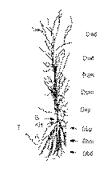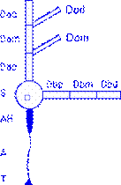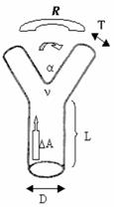
(1A) (1B) (1C)

Figure1,(1A) in rat hippocampalCA1pyramidal neurons.

(1b) key positions: D, dendrites; S, cell body; AH, the beginning of the axon shaft mounds; A,axon; T,axon terminal. dendrites of the type: e, a single equivalent cylinder dendritic body; a, dendritic top; b, DC-based terminal; o, dendritic tilt. dendrites levels: (p)has recently ended, (m) the middle end, and (d) the most remote-relative to cell body.

(1c)neurons in the local form of simple geometric features:Dtrunk diameter,Tthe top diameter,Lthe length of the trunk,△Atrunk taper,Rbranch ratio(before and after the branch length relationship), power-law branch ν(before and after the branchdiameterrelationship), the branch angle α.
Understanding of characteristics of neurons, the basic problem is the classification of neurons. Currently, on a simple classification of neurons are: (1) According to the number of processes can be divided into a multi-polar neuron neurons; bipolar neurons and unipolar neurons. (2) According to the function of neurons and can be divided into mainly neurons, sensory neurons, motor neurons and intermediate neurons and so on. The main function of the primary neurons is the output of neural circuits of the information.For example, pyramidal neurons in the cerebral cortex, cerebellar cortex neurons in Puken wild and so on. Sensory neurons, and stimulation of their acceptance into nerve impulses. Between neurons, is between sensory neurons and motor neurons liaison between the. Motor neurons, they will be the central issue of the impulse conduction to muscles and other activities organs. Location in different tissues, the middle class and form neurons, a great deal. The more evolved animals, the more neurons in the middle to form a network of central nervous system more complex.
How to identify the distinction between different types of neurons, this problem has still not been resolved scientifically. Biological differences between neurons primarily by anatomical geometry and potential distribution of two factors. Geometry of neurons obtained mainly through staining, the potential distribution through theintracellular microelectrode recording obtained puncture. The potential use of neural distribution patterns distinguish the type of neurons is more complex, mainly related neuronsHodgkin-Huxleymodel and theRall cable model of the discrete form of(compartment model neurons). Only consider the problem geometry of neurons to study how to use the geometric characteristics of neurons, neuron by mathematical modeling of a given spatial form classification method, the geometry of neurons more accurately according to classification.

Neuronal geometry of spaceresearch program in human brain is an important project, NeuroMorpho.Orgcontains a large number of neurons in the geometry of data, etc.,are still increasing, where you can get a lot of data in spatial form of neurons, for example, AppendixAand AppendixC. For the geometry characteristics of neurons to study the hot issues, experts focus on different indicators to describe the different morphological characteristics of neurons, such as Figure1, the following gives a rough spatial characterization of neurons in AppendixAand AppendixCwith the standard A. SWC format given characterization. You need to complete the task:
(1) Using AppendixAand in AppendixCsampleneuralelement geometry of space, find out in AppendixCin5categories the geometric characteristics of neurons (neurons and the middle segment3classes), give a space for morphological classification of neurons approach.
(2) AppendixBanother20neurons form of data, they can determine what type of neurons. In the given data, it is necessary to introduce or define the name of new neurons.
(3) form of complexity and diversity of neurons, neuron classification problem identification has still not resolved, you can propose a classification of neurons, all neurons classified by geometric features. You would give biologists to recommend the naming of neurons (AppendixAand AppendixCof neurons is more important category, the actual should be a lot of other categories).
(4) in accordance with your method of morphological classification of neurons, can determine the animal nervous system in different classes of neurons in the same morphological characteristics there a difference? For example, AnnexAin wild pigs Puken neurons and neurons in rats Puken wild, their characteristics there a difference?
(5) the actual shape of neurons, with the passage of time, dendrites and axons continue to grow and change, you can predict the growth of neuronal morphology change? These morphological changes on the geometry of your features to determine what effect.

Reference1, Neuron Data Source:http://neuromorpho.org/neuroMorpho/index.jsp
Reference2, neurons Source: http://senselab.med.yale.edu/NeuronDB/ndbRegions.asp?sr=1
Reference3, Neuron Data Source: http://krasnow.gmu.edu/L-Neuron/L-Neuron/database/index.html # Scorcioni
Reference4, neurons Source: http://www.compneuro.org/CDROM/nmorph/index/topindex_tn.html

Note 1, the title only consider neurons in morphological characteristics, such asneuronal cell body surface area, dry the number, branch number, branch number,width, height,depth,diameter,length,surface area,volume,stem taper, branch power law, branch point or other morphological parameters, geometric characteristics describe the spatial form of neurons.
Note 2, the appendix describes the file format, three-dimensional neural data is the standard A. SWC format. A neuron can be based on the discrete form of spatial structure for many AV, the AV withA. SWC format description.A. SWC format, each line containing neurons in a compartment of the7standard data points:
(1) a compartment of the label
(2) the type of atrioventricular (such as 0 - to be determined, 1 - cell body, 2 - axon, 3 - DC, 4 - tip of dendrites, etc.)
(3) compartment of the x coordinate
(4) compartment of the y coordinate
(5) AV of the z coordinate
(6) the radius of AV
(7) and the mother of the atrioventricular atrioventricular label

5classes of neurons and the major characteristics of spatial form
(The following graphics and data characteristics of the rough space characterization of neurons, only neurons are given about the different types of knowledge, but the standard description of geometry features. Samples of each type of neuron and neurons need to determine the integrity of the data, see AnnexCData )

(1) motor neurons, detailed spatial data, see AppendixC1,Motor Neuron-A
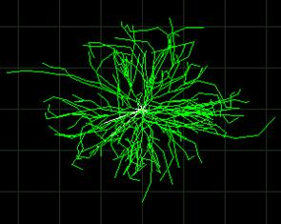
Figure2 motor neuron
http://neuromorpho.org/neuroMorpho/neuron_info.jsp?neuron_name=v_e_moto5
Soma Surface: | 29910.9
Number of Stems: | 15
Number of Bifurcation: | 151
Number of Branch: | 331
Width: | 2541
Height: | 1922
Depth: | 2077
Diameter: | 3.80034
Length: | 107,519
Surface: | 593,005
Volume: | 413,374
Euclidean Distance: | 1713.41
Path Distance: | 1938.85
Branch Order: | 9
Contraction: | 0.920859
Fragmentation: | 706
Partition Asymmetry: | 0.529978
Rall's Ratio: | 1.02621
Bifurcation angle Local: | 53.5559
Bifurcation angle Remote: | 52.4336

(2) Puken field neurons, detailed spatial data, see AppendixC2,Purkinje Neuron-A
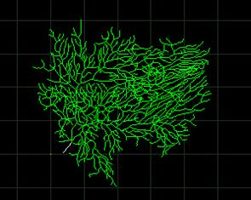
Figure3 Puken field neurons
http://neuromorpho.org/neuroMorpho/neuron_info.jsp?neuron_name=e1cb4a5
Soma Surface: | 511.087
Number of Stems: | 1
Number of Bifurcation: | 343
Number of Branch: | 688
Width: | 120.82
Height: | 105.78
Depth: | 7
Diameter: | 0.637274
Length: | 4461.66
Surface: | 9947.93
Volume: | 2149.76
Euclidean Distance: | 135.398
Path Distance: | 188.452
Branch Order: | 23
Contraction: | 0.936457
Fragmentation: | 4053
Partition Asymmetry: | 0.541038
Rall's Ratio: | 1.87855
Bifurcation angle Local: | 79.5819
Bifurcation angle Remote: | 65.0169

(3) pyramidal neurons,detailed spatial data, see AppendixC3,pyramidal Neuron-A
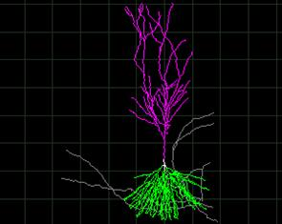
Figure4 pyramidal neurons
http://neuromorpho.org/neuroMorpho/neuron_info.jsp?neuron_name=cell2zr

Soma Surface: | 610.356
Number of Stems: | 6
Number of Bifurcation: | 87
Number of Branch: | 185
Width: | 232.5
Height: | 715.5
Depth: | 339.5
Diameter: | 0.978679
Length: | 15597.1
Surface: | 46747.5
Volume: | 16971.4
Euclidean Distance: | 614.772
Path Distance: | 1105.38
Branch Order: | 12
Contraction: | 0.864059
Fragmentation: | 2560
Partition Asymmetry: | 0.563797
Rall's Ratio: | 1.42595
Bifurcation angle Local: | 65.342
Bifurcation angle Remote: | 49.1067

(4a) bipolar neurons in the middle of a detailed spatial data, see AppendixC4,Bipolar interneuron-A

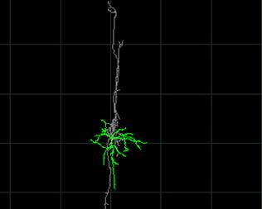
Figure5 bipolar neurons in the middle
http://neuromorpho.org/neuroMorpho/neuron_info.jsp?neuron_name=C240300C1

Soma Surface: | 426.754
Number of Stems: | 5
Number of Bifurcation: | 61
Number of Branch: | 131
Width: | 233.31
Height: | 299.61
Depth: | 127.1
Diameter: | 0.460326
Length: | 5821.4
Surface: | 7299.01
Volume: | 866.528
Euclidean Distance: | 709.551
Path Distance: | 973.303
Branch Order: | 12
Contraction: | 0.857727
Fragmentation: | 1545
Partition Asymmetry: | 0.571631
Rall's Ratio: | 1.7569
Bifurcation angle Local: | 86.5934
Bifurcation angle Remote: | 74.4265

(5B) neurons in the middle of the three most detailed spatial data, see AppendixC5,tripolar interneuron-A
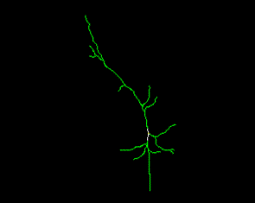
Figure6, neurons in the middle of the three pole
http://neuromorpho.org/neuroMorpho/neuron_info.jsp?neuron_name=P17-DEV169

Soma Surface: | 1318.45
Number of Stems: | 3
Number of Bifurcation: | 10
Number of Branch: | 25
Width: | 180.33
Height: | 358.36
Depth: | 18.21
Diameter: | 1.66526
Length: | 919.181
Surface: | 4545.29
Volume: | 1860.69
Euclidean Distance: | 281.217
Path Distance: | 321.105
Branch Order: | 5
Contraction: | 0.924074
Fragmentation: | 384
Partition Asymmetry: | 0.607576
Rall's Ratio: | 1.6242
Bifurcation angle Local: | 58.3224
Bifurcation angle Remote: | 58.6855

(5C) between multipolar neurons, detailed spatial data, see AppendixC6,Multipolar interneuron-A
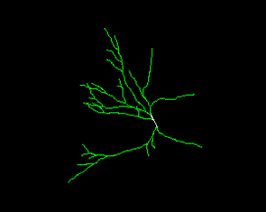
Figure7, the middle of a multi-polar neuron
http://neuromorpho.org/neuroMorpho/neuron_info.jsp?neuron_name=P32-DEV134

Soma Surface: | 1976.34
Number of Stems: | 5
Number of Bifurcation: | 20
Number of Branch: | 49
Width: | 274.84
Height: | 331.6
Depth: | 33.18
Diameter: | 2.05835
Length: | 2304.9
Surface: | 14270.3
Volume: | 7083.65
Euclidean Distance: | 259.407
Path Distance: | 299.921
Branch Order: | 5
Contraction: | 0.940103
Fragmentation: | 838
Partition Asymmetry: | 0.48866
Rall's Ratio: | 1.8121
Bifurcation angle Local: | 41.7379
Bifurcation angle Remote: | 39.2421

(5) sensory neurons, detailed spatial data, see AppendixC7,Sensory Neuron-A
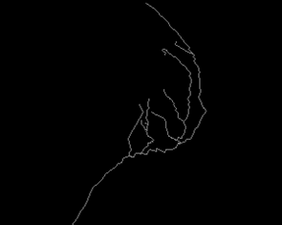
Figure8 sensory neurons
http://neuromorpho.org/neuroMorpho/neuron_info.jsp?neuron_name=L-7-10-155
Soma Surface: | 0
Number of Stems: | 0
Number of Bifurcation: | 11
Number of Branch: | 23
Width: | 107.04
Height: | 138.65
Depth: | 49.87
Diameter: | 1.72494
Length: | 616.9
Surface: | 3477.05
Volume: | 1913.47
Euclidean Distance: | 111.32
Path Distance: | 161.599
Branch Order: | 5
Contraction: | 0.874726
Fragmentation: | 225
Partition Asymmetry: | 0.430303
Rall's Ratio: | 1.32709
Bifurcation angle Local: | 83.3988
Bifurcation angle Remote: | 69.9301

